|  |  |  |
| --- | --- | --- |
|  | |  |
|  |  | |
|  | AquiMod modelling of groundwater level hydrographs in the Anglian Water Services' area | |
|  | Topic  Report | |
|  |  | |
|  |  | |
|  |  | |

|  |  |  |
| --- | --- | --- |
|  |  | BRITISH GEOLOGICAL SURVEY  Monitoring and Forecasting TOpic  Commissioned REPORT CR/20/056 |
|  |  |
| The National Grid and other Ordnance Survey data  © Crown Copyright and database rights 2020. Ordnance Survey Licence  No. 100021290 EUL.  *Keywords*  Groundwater level hydrographs; AquiMod modelling;.  *Front cover*  Observed and simulated groundwater level time-series.  *Bibliographical reference*  Bunting, S.Y., Jackson, C.R., Mackay, J.D. 2020. AquiMod modelling of groundwater level hydrographs in the Anglian Water Services' area. *British Geological Survey Commissioned Report*, CR/20/056. 18pp.  Copyright in materials derived from the British Geological Survey’s work is owned by UK Research and Innovation (UKRI) and/or the authority that commissioned the work. You may not copy or adapt this publication without first obtaining permission. Contact the BGS Intellectual Property Rights Section, British Geological Survey, Keyworth,  e-mail ipr@bgs.ac.uk. You may quote extracts of a reasonable length without prior permission, provided a full acknowledgement is given of the source of the extract.  Maps and diagrams in this book use topography based on Ordnance Survey mapping. | AquiMod modelling of groundwater level hydrographs in the Anglian Water Services' area |
|  |
| © *UKRI 2020. All rights reserved* | Keyworth, Nottingham British Geological Survey 2020 |

**BRITISH GEOLOGICAL SURVEY**

The full range of our publications is available from BGS  
shops at Nottingham, Edinburgh, London and Cardiff (Welsh publications only) see contact details below or shop online at www.geologyshop.com

The London Information Office also maintains a reference collection of BGS publications, including maps, for consultation.

We publish an annual catalogue of our maps and other publications; this catalogue is available online or from   
any of the BGS shops.

*The British Geological Survey carries out the geological survey of Great Britain and Northern Ireland (the latter as   
an agency service for the government of Northern Ireland), and of the surrounding continental shelf, as well as basic research projects. It also undertakes programmes of technical aid in geology in developing countries.*

*The British Geological Survey is a component body of   
UK Research and Innovation.*

*British Geological Survey offices*

**Nicker Hill, Keyworth,   
Nottingham NG12 5GG**

Tel 0115 936 3100

**BGS Central Enquiries Desk**

Tel 0115 936 3143  
email enquiries@bgs.ac.uk

**BGS Sales**

Tel 0115 936 3241  
email sales@bgs.ac.uk

**The Lyell Centre, Research Avenue South,   
Edinburgh EH14 4AP**

Tel 0131 667 1000   
email scotsales@bgs.ac.uk

**Natural History Museum, Cromwell Road,   
London SW7 5BD**

Tel 020 7589 4090   
Tel 020 7942 5344/45   
email bgslondon@bgs.ac.uk

**Cardiff University, Main Building, Park Place,   
Cardiff CF10 3AT**

Tel 029 2167 4280

**Maclean Building, Crowmarsh Gifford,   
Wallingford OX10 8BB**

Tel 01491 838800

**Geological Survey of Northern Ireland, Department of Enterprise, Trade & Investment, Dundonald House, Upper Newtownards Road, Ballymiscaw,   
Belfast, BT4 3SB**

Tel 01232 666595

www.bgs.ac.uk/gsni/

**Natural Environment Research Council, Polaris House,  
North Star Avenue, Swindon SN2 1EU**

Tel 01793 411500 Fax 01793 411501  
www.nerc.ac.uk

**UK Research and Innovation, Polaris House,   
Swindon SN2 1FL**

Tel  01793 444000   
www.ukri.org

Website www.bgs.ac.uk  
Shop online at  [www.geologyshop.com](http://www.geologyshop.com)

# Foreword

This report describes the work carried out by BGS for Anglian Water Services to develop AquiMod groundwater models to simulate observations borehole groundwater level hydrographs. The BGS project reference is IDA 275904.

Groundwater hydrographs have been modelled at ten sites located across aquifers of eastern England. The report describes how to update the model input files and run the models as new climate and groundwater level data become available.

# Acknowledgements

The authors acknowledge the support of Anne Bravery at Anglian Water Services in providing the climate and groundwater level time-series data used to setup, run, and evaluate the models.

# Contents

Foreword i

Acknowledgements i

1 Introduction 1

1.1 AquiMod modelling software 2

1.2 Observation boreholes modelled 2

2 Methodology 3

2.1 Input data 3

2.2 Model calibration 3

3 Results 4

3.1 Model performance 4

4 Updating and running the models 9

4.1 Running a model 9

References 11

**FIGURES**

Figure 1. Location of observations boreholes modelled. 1

Figure 2 Observed and simulated groundwater level for Castle Farm borehole 5

Figure 3 Observed and simulated groundwater level for Dullingham borehole 5

Figure 4 Observed and simulated groundwater level for Grange De Lings borehole 5

Figure 5 Observed and simulated groundwater levels for Horkstow Road, Barton borehole 6

Figure 6 Observed and simulated groundwater level time-series for Leasingham borehole 6

Figure 7 Observed and simulated groundwater level for Old Thurgarton Hall borehole 6

Figure 8 Observed and simulated groundwater level for Springhead Farm borehole 7

Figure 9 Observed and simulated groundwater level for Stow 2 Oakholt borehole 7

Figure 10 Observed and simulated groundwater level for Tank Hall borehole 7

Figure 11 Observed and simulated groundwater level for The Arms borehole 8

Figure 12 Format of observations.txt model input file 9

Figure 13 Format of input.txt model input file 10

**TABLES**

Table 1. Observation borehole details 2

Table 2. Period of groundwater level records 3

Table 3. Best-fit model structure and associated NSE for each site 4

# Introduction

An AquiMod groundwater model (Mackay et al., 2014) was constructed and calibrated to simulate groundwater level time-series at 10 observation boreholes located across eight aquifers (Figure 1, Table 1) in the Anglian Water Services (AWS) operating area. This report describes the basic structure of the model, how it was calibrated, and how the model can be updated with newly collected climate and groundwater level data.

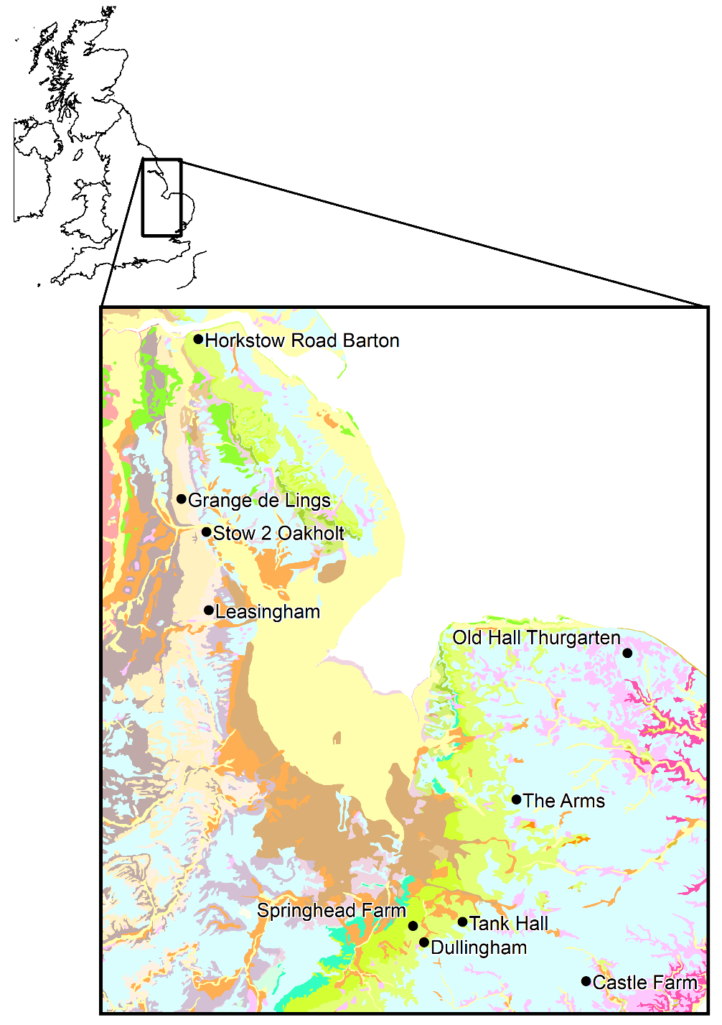

Figure . Location of observations boreholes modelled.

For geological map details see the Geology of Britain viewer <https://mapapps.bgs.ac.uk/geologyofbritain/home.html>

## AquiMod modelling software

AquiMod is a lumped parameter computer model that has been developed to simulate groundwater level time-series at observation boreholes in aquifers by linking simple hydrological algorithms. The model is composed of three components:

1. A soil water balance model partitioning rainfall between evaporation, surface runoff and potential recharge.
2. An unsaturated zone transfer function that can delay and spread the arrival of potential recharge to the water table.
3. A saturated groundwater flow module that simulates flow through, and changes in groundwater head within, a representative aquifer block. The saturated zone module is used to calculate the modelled groundwater level time-series which is then used to assess the skill of the model against observed historical groundwater levels.

AquiMod can be applied to any groundwater catchment around an observation borehole with observed groundwater level time-series data. Each model is calibrated using a Monte Carlo approach and historical data to provide information on the behaviour of groundwater levels beyond observational records.

Model parameter sets based on basic hydrogeological parameters of the aquifer are used to run the model and a measure of the goodness-of-fit (Nash Sutcliffe Efficiency) of the simulated groundwater levels to the observations is calculated. The best model is selected by examining the ensemble of historical simulations.

For more information about the background and model development, see the AquiMod User Guide (Mackay et al., 2014).

Version 1.0 of AquiMod can be downloaded for free from the BGS web site: <https://www.bgs.ac.uk/research/environmentalModelling/aquimod.html>. However in this study a different unreleased ‘development’ version of AquiMod was used because it includes two additional saturated groundwater model components that enable the specification of a greater degree of heterogeneity in the aquifer. These components, named Q2K2S2 and Q3K3S2, include two and three outlets respectively, each with an associated hydraulic conductivity and storage coefficient parameter.

## Observation boreholes modelled

Details for the 10 observations boreholes situated in the eight aquifers selected by AWS for AquiMod modelling of their groundwater level records are listed in Table 1

Table . Observation borehole details

|  |  |  |  |  |
| --- | --- | --- | --- | --- |
| **Observation borehole** | **Aquifer** | **Environment Agency code** | **Easting** | **Northing** |
| Castle Farm | East Suffolk Gipping Chalk | TM04/695 | 606542 | 249210 |
| Dullingham | West Suffolk Lodes Chalk | TL65/050 | 563063 | 259601 |
| Grange de Lings | North Lincolnshire Limestone | 1/610 | 498000 | 378170 |
| Horkstow Rd Barton | North Lincolnshire Chalk | 5/108 | 502560 | 420910 |
| Leasingham | Central Lincolnshire Limestone | 2/544 | 505360 | 348430 |
| Old Hall Thurgarten | East Norfolk Bure and Ant Chalk | TG13/765A | 617603 | 336930 |
| Springhead Farm | West Suffolk Lodes Chalk | TL66/094 | 560090 | 263996 |
| Stow 2 Oakholt | Central Lincolnshire Limestone | 2/566 | 504720 | 369380 |
| Tank Hall | West Suffolk Lark Chalk | TL76/110 | 573361 | 265052 |
| The Arms | West Norfolk Wissey Chalk | TL89/019 | 587801 | 297801 |

# Methodology

## Input data

The model for each site was driven by time-series of historical rainfall and potential evapotranspiration and calibrated against the observed groundwater level time-series. Each simulation started five years prior to the first groundwater level observation to ‘spin up’ the model i.e. to remove the effect of initial conditions on simulated levels.

Observed groundwater levels were provided by AWS for each observation borehole. A number of the provided records become telemetered/automatically logged part way through the record, increasing the frequency of measurements.

Daily rainfall and monthly potential evapotranspiration licensed by AWS from the UK Met Office were used to drive the models.

Table . Period of groundwater level records

|  |  |
| --- | --- |
| **Observation borehole** | **Period of groundwater level observations** |
| Castle Farm | 23/03/1967 - 18/03/2020 |
| Dullingham | 11/11/1982 - 27/04/2020 |
| Grange de Lings | 17/03/1975 - 07/04/2020 |
| Horkstow Road Barton | 28/04/1980 - 07/04/2020 |
| Leasingham | 26/09/1972 - 07/04/2020 |
| Old Hall Thurgarten | 06/09/1984 - 31/03/2020 |
| Springhead Farm | 15/04/1983 - 27/04/2020 |
| Stow 2 Oakholt | 06/03/1972 - 07/04/2020 |
| Tank Hall | 16/08/1984 - 05/02/2020 |
| The Arms | 01/01/1971 - 03/04/2020 |

## Model calibration

The performance of four saturated groundwater model components was evaluated at each site:

1. Q2K2S1
2. Q2K2S2
3. Q3K3S1
4. Q3K3S3

For each structure, the soil, unsaturated zone and saturated zone parameters were adjusted within a Monte Carlo processes to calibrate the model. The Nash-Sutcliffe Efficiency was used to calculate error between the simulated and observed groundwater level time-series.

# Results

## Model performance

The performance of each model, as quantified by the NSE, and the best model structure identified are listed in Table 3. Subjectively, one might describe model performance according to the following categorisation:

* 0.5 ≤ NSE < 0.6: Reasonable
* 0.6 ≤ NSE < 0.7: Good
* 0.7 ≤ NSE < 0.8: Very Good
* NSE > 0.8: Excellent

To avoid biasing the calibration of the model, the periods of daily data within the Dullingham, Springhead Farm and Tank hall records were resampled on to a monthly time-step.

Table . Best-fit model structure and associated NSE for each site

|  |  |  |
| --- | --- | --- |
| **Site** | **Best saturated groundwater model component** | **NSE** |
| Castle Farm | Q3K3S1 | 0.785 |
| Dullingham | Q3K3S3 | 0.784 |
| Grange De Lings | Q3K3S3 | 0.763 |
| Horkstow Road Barton | Q3K3S1 | 0.594 |
| Leasingham | Q3K3S3 | 0.709 |
| Old Hall Thurgarten | Q3K3S1 | 0.512 |
| Springhead Farm | Q3K3S1 | 0.704 |
| Stow 2 Oakholt | Q3K3S3 | 0.804 |
| Tank Hall | Q3K3S3 | 0.774 |
| The Arms | Q2K2S2 | 0.863 |

The following figures show the comparison between the observed groundwater levels and the simulated time-series produced by the best 100 model parameter sets (pink). The simulation with the highest NSE is plotted in red.

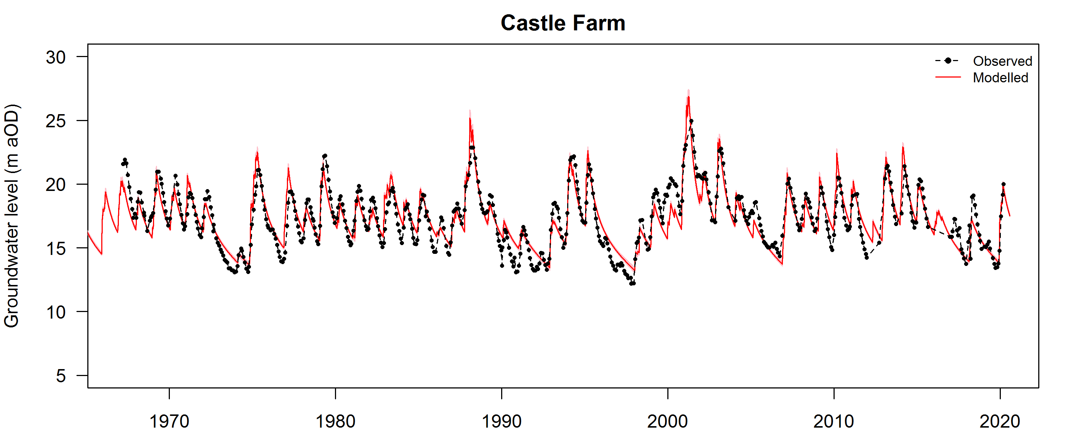

Figure Observed and simulated groundwater level for Castle Farm borehole

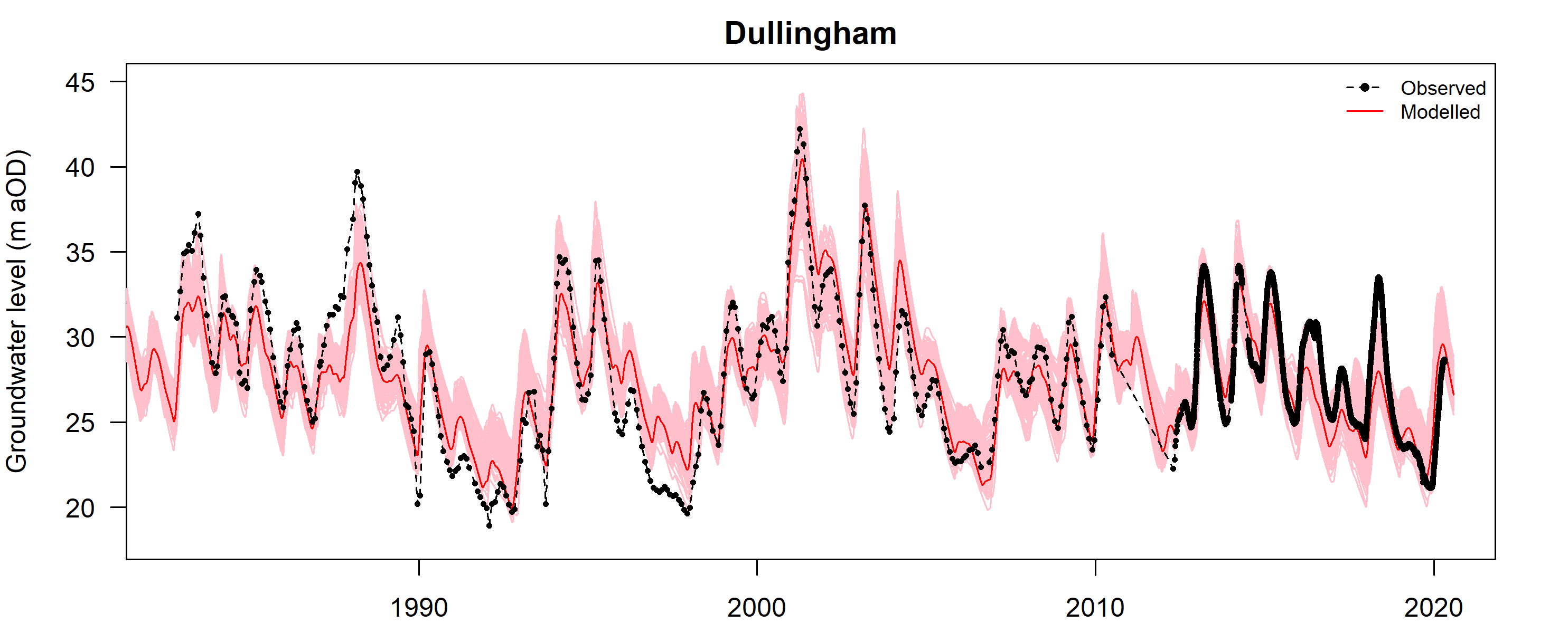

Figure Observed and simulated groundwater level for Dullingham borehole

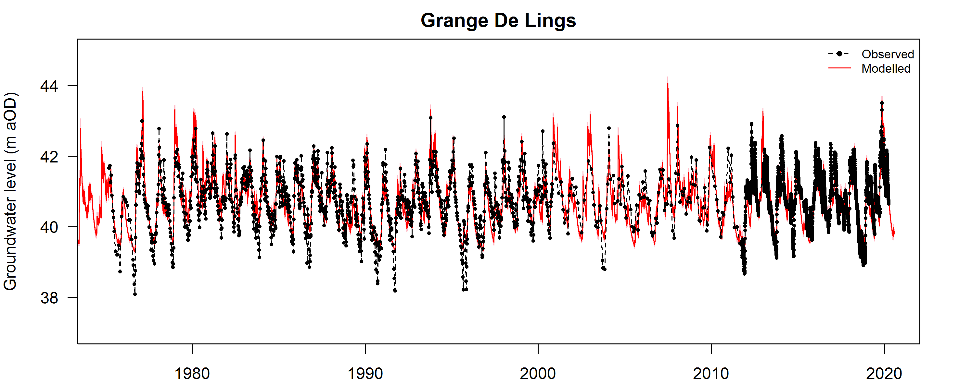

Figure Observed and simulated groundwater level for Grange De Lings borehole

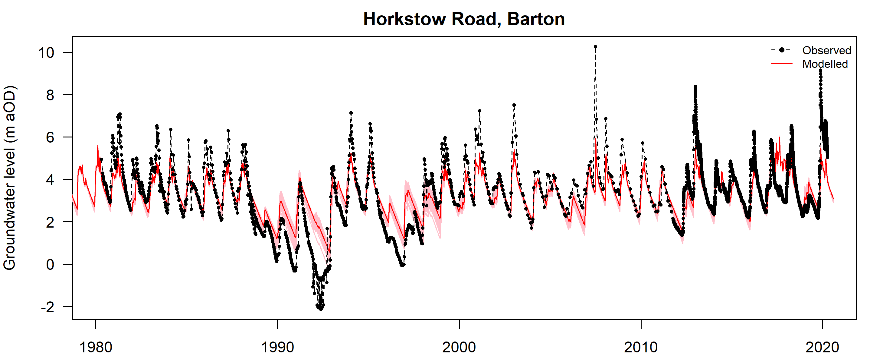

Figure Observed and simulated groundwater levels for Horkstow Road, Barton borehole

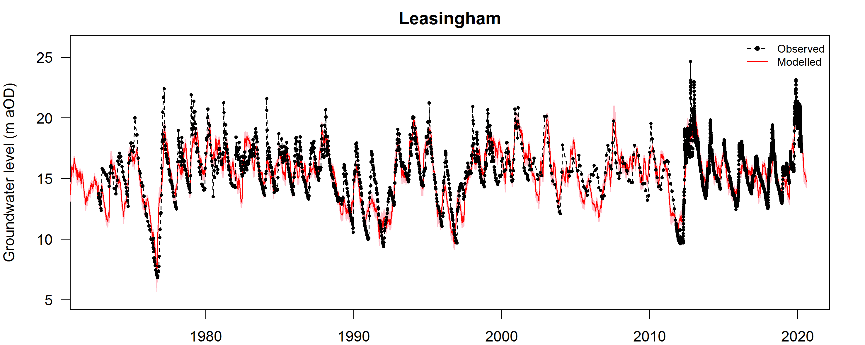

Figure Observed and simulated groundwater level time-series for Leasingham borehole

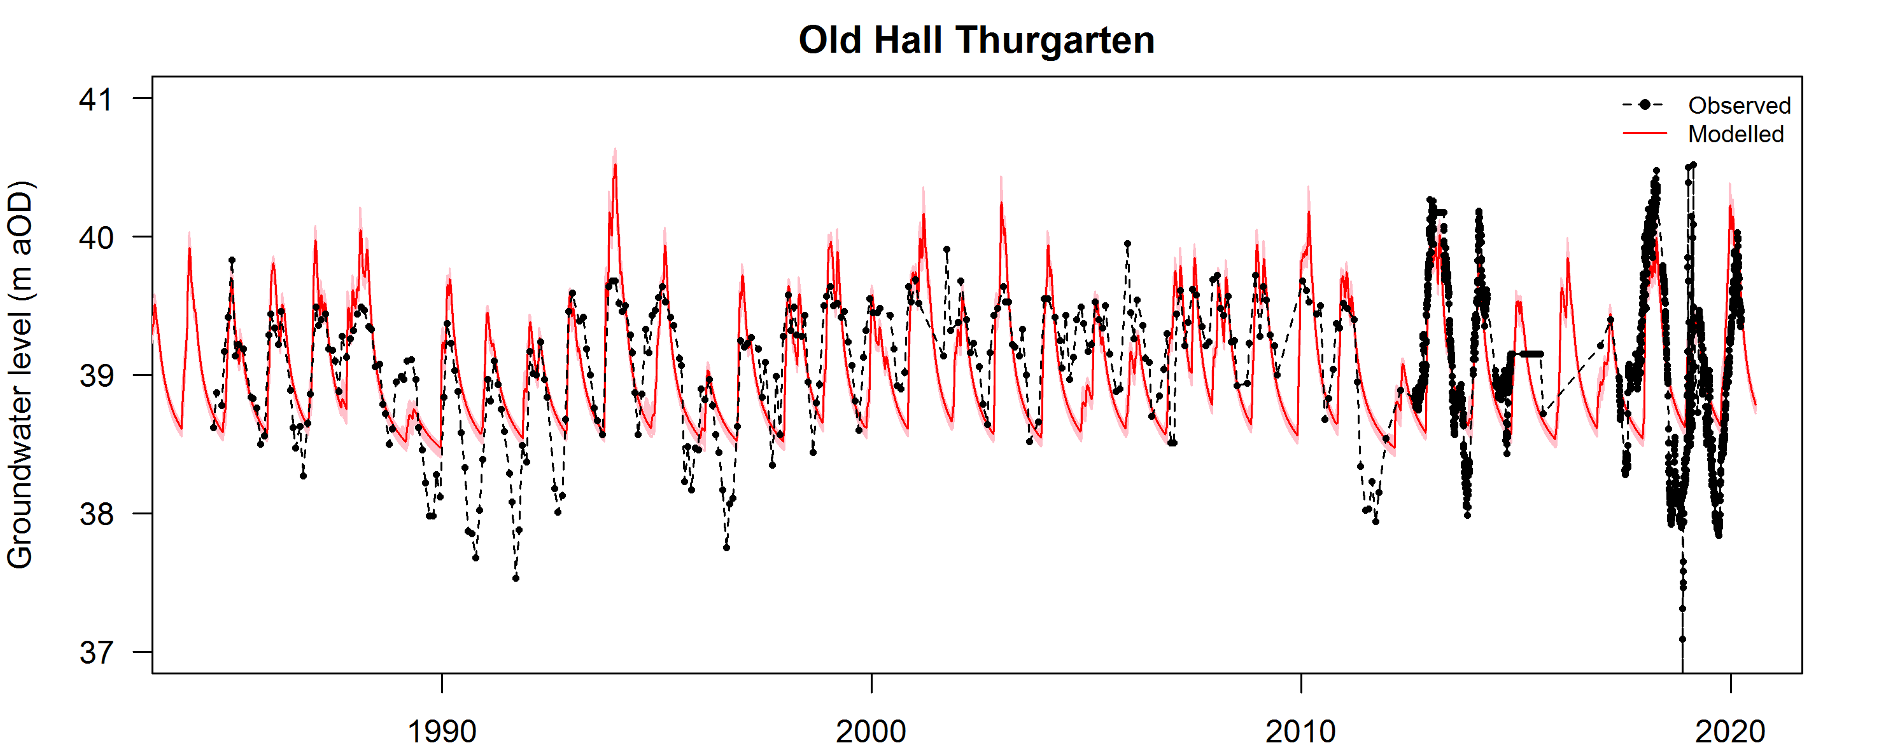

Figure Observed and simulated groundwater level for Old Thurgarton Hall borehole

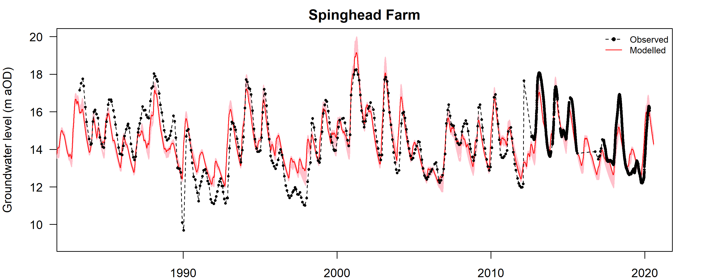

Figure Observed and simulated groundwater level for Springhead Farm borehole

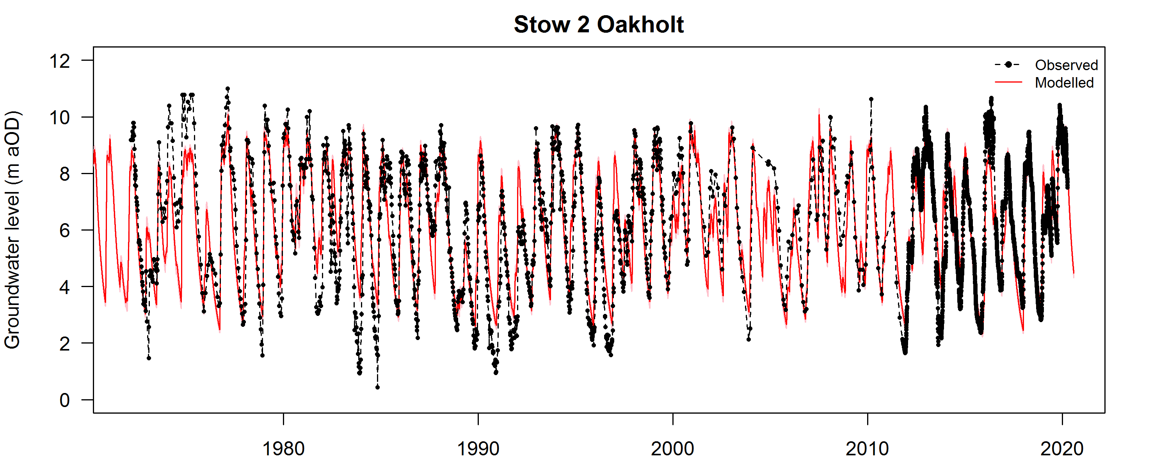

Figure Observed and simulated groundwater level for Stow 2 Oakholt borehole

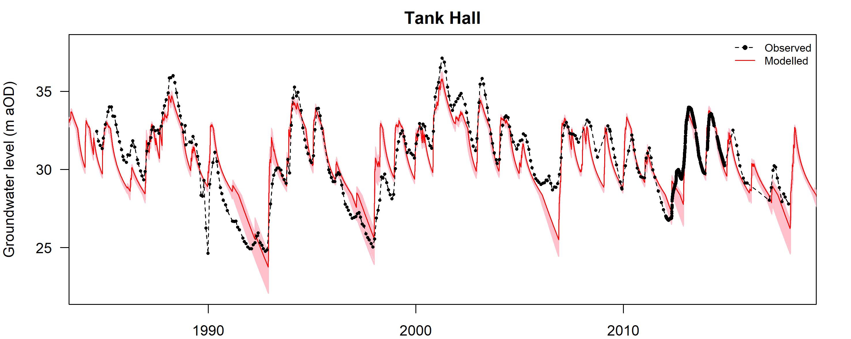

Figure Observed and simulated groundwater level for Tank Hall borehole

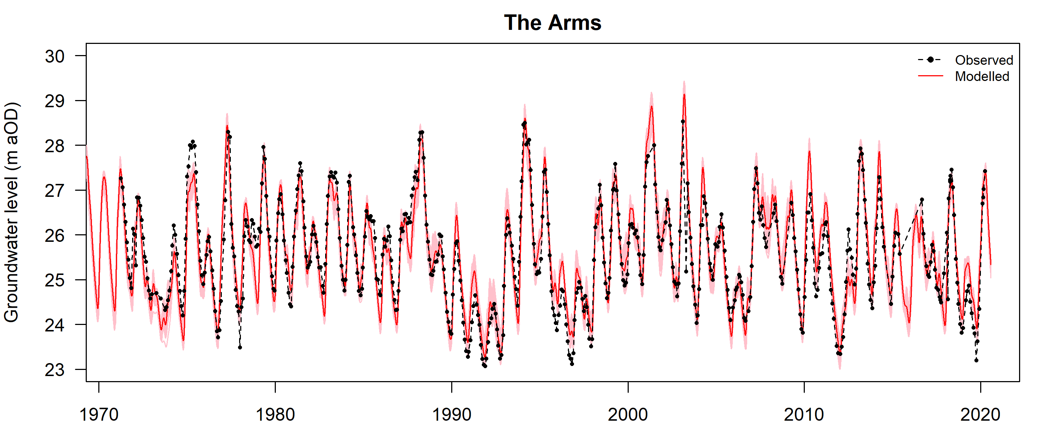

Figure Observed and simulated groundwater level for The Arms borehole

# Updating and running the models

## Running a model

See Section 2 of the AquiMod User Manual (Mackay et al., 2014) for details about how to install AquiMod. To run the version of AquiMod provided to AWS to run the 10 models described in this report type the following on the command line:

AquiModAWS *path*

where *path* is the location of the folder containing the specific model e.g.

D:\AquiModModelling\Leasingham

### Updating the input files

See Section 5 of the AquiMod User Manual to understand the file structure used for each model. The observations.txt file must be updated with new data to provide a continuous time-series of data. For the AquiModAWS version of the software, observations.txt requires an additional column of data compared to the publicly available version of the code. It has the format shown in Figure 1 with columns of data separated by a space or a tab.

|  |
| --- |
| NUMBER OF OBSERVATIONS  17532  DAY MONTH YEAR RAIN PET GWL ABS SM  01 01 1970 0.28 0.31 41.0 0 -9999  02 01 1970 0.15 0.31 -9999 0 -9999  03 01 1970 0.0 0.31 -9999 0 -9999  . . . . . . . .  . . . . . . . .  . . . . . . . . |

Figure Format of observations.txt model input file

The rainfall, PET and abstraction (ABS) series must be complete, but where there are missing groundwater level (GWL) or soil moisture (SM) data a value of -9999 must be input. A groundwater level must be provided for the first day of the simulation. Abstraction has not been included in any of the models. The soil component of AquiMod can be calibrated to soil moisture data but similarly no soil moisture data have been included in the input files. Rainfall, PET and abstraction are specified in mm day-1. Groundwater level is specified in metres above a datum. The units of soil moisture are mm.

### Running the model

Running of the model is controlled using the file input.txt (Figure 13). To run a previously calibrated model AquiMod is run in its ‘evaluation’ simulation mode (e). To run one or more from the ensemble of ‘behavioural’ models identified during calibration change the integer value associated with the ‘Number of runs’ item in input.txt. To run just the best model set this to 1. Other variables should not be changed after calibration.

The AquiMod executable is run using the Windows command prompt which can be accessed by typing ‘cmd’ into the search bar of the Start menu and hitting the return key. Refer to section 4.1 above or section 2.2 in the AquiMod User Manual for more details about how to run a model.

### Interpreting results

After executing the AquiMod command, if the final line of the input.txt file instructed the model to write output files, these will be generated for each of the three model components (soil, unsaturated zone, saturated zone), and stored in the ‘Output’ folder. The simulated groundwater level time-series will be stored in files named after the model structure used e.g. Q3K3S3_TimeSeries1. If more than one model was run, these will be stored in separate output files, numbered consecutively.

|  |
| --- |
| Model IDs  1 1 6  Simulation mode  e  Calibrated variable (GWL = g, Soil moisture = s)  g  Number of runs  1  Objective function  1  Spin-up period  1826  Acceptable model threshold (calibration only)  0.5  Maximum number of acceptable models (calibration only)  100  Write model output files  Y Y Y |

Figure Format of input.txt model input file

# References

British Geological Survey holds most of the references listed below, and copies may be obtained via the library service subject to copyright legislation (contact libuser@bgs.ac.uk for details). The library catalogue is available at: <https://envirolib.apps.nerc.ac.uk/olibcgi>

Hough, M.N., Jones, R.J.A. 1997. The United Kingdom Meteorological Office rainfall and evaporation calculation system: MORECS version 2.0 – an overview. Hydrology and Earth System Science, 1(2), 227-239.

Mackay, J.D., Jackson, C.R., Wang, L. 2014. AquiMod User Manual (v1.0). British Geological Survey Open Report, OR/14/007. 42pp. <http://nora.nerc.ac.uk/id/eprint/507668/>